

**NEHA OHRI -S18000650030**





Big data is a term for data sets that are so large or complex that traditional data processing applications are inadequate to deal with them.  **Big data** challenges include capturing **data**, **data** storage,**data** analysis, search, sharing, transfer, visualization, querying, updating and information private.

**4V’S OF Big Data**

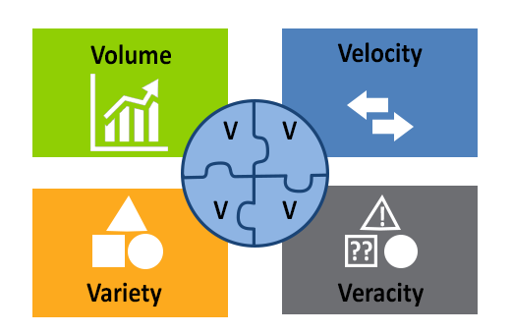

**Volume**

It is estimated that, on an average, 2.3 trillion gigabytes of data aregenerated every day. Forget analyzing, simply capturing such quantities of data is impractical. Most companies in the US have at least 100,000 gigabytes of data stored; and almost all of them will tell you that they aren’t collecting enough data.

The right approach is to fight the urge of making your company’s server a data dump. Efforts must be made to employ the right software to filter the relevant data.

#### Variety

Along with quantity, the diversity of data is equally important. The variety in data can be in terms of the devices or the sources of data generation.

*Velocity*

Not only is the volume of data ever increasing, but the rate of data generation (from the Internet of Things, social media, etc.) is increasing as well.

*Veracity*

Not all data is good. In fact, unfiltered data is more likely to be bad than good. Although data quality and usability depends largely on the source, you can never rule out junk.

This unreliability of data makes many business heads reluctant to rely on information analysis. That’s the wrong approach.

**HADOOP**



Apache Hadoop is an open-source software framework used for distributed storage and processing of very large data sets.It consists of computer clusters built from commodity hardware. All the modules in Hadoop are designed with a fundamental assumption that hardware failures are a common occurrence and should be automatically handled by the frame.

**HIVE**



Apache Hive is a data warehouse infrastructure built on top of Hadoop for providing data summarization, query, and analysis.

Hive gives an SQL-like interface to query data stored in various databases and filesystems that integrate with Hadoop.

 It is built on top of Hadoop and developed by Facebook.Hive provides a way to query the data using a SQL-like query language called HiveQL(Hive query Language).

Internally, a compiler translates **HiveQL** statements into **MapReduce** jobs, which are then submitted to**Hadoop framework** for execution.

**Apache Pig**



Apache Pig is a high-level platform for creating programs that run on Apache Hadoop. The language for this platform is called Pig Latin.

Pig can execute its Hadoop jobs in Map Reduce, Apache Tez, or Apache Spark. Pig Latin abstracts the programming from the Java Map Reduce idiom into a notation which makes Map Reduce programming high level, similar to that of SQL for RDBMS.

Pig Latin can be extended using User Defined Functions (UDFs) which the user can write in Java, Python, JavaScript, Ruby or Groovy and then call directly from the language.

**MAP REDUCE**

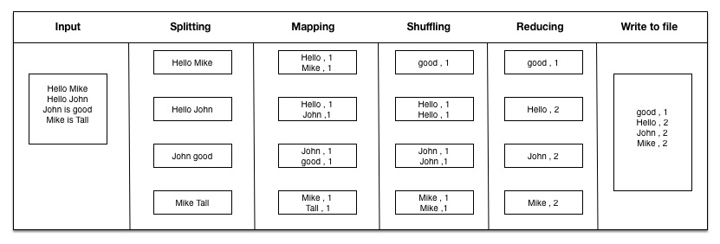

TaskTracker split the file and pass to mapper and mapper converts it into <Key, Value> map. As per above example it uses TextInputFormat to split input file into lines.Mapper split the line into word and uses Text to store word as key and IntWritable to store 1 as count value. Mapper passes map to OutputCollector, which intern shuffle and sort the map. Combiner is optional which optimize the reducer on node level. Here we are using Reducer as Combiner to combine the output to a single.

SQOOP



Sqoop is a tool designed to transfer data between Hadoop and relational database servers. It is used to import data from relational databases such as MySQL, Oracle to Hadoop HDFS, and export from Hadoop file system to relational databases.

**H1-B CASE STUDY**

**PROJECT OBJECTIVE**--- The H1- B is an employment –based, non-immigrant visa category for temporary foreign workers in the United States. For a foreign national to apply H1-B Visa, an US employer must offer a job and petition for H1-B visa with the US immigration department. This is the most common visa status applied for and held by international students once they complete college/higher education (Maters, Ph.D.) and work in a full-time position.

**Hardware Requirements**-

6 GB RAM

64Bit OS

**Technology Requirements**-

• Apache Hadoop

• MapReduce

• Hive

• Pig

• SQOOP

**Software Used**–

• VMware

• Ubuntu

• Eclipse

• MySQL

**Assumptions:**

• VMware Workstation – Configurations are set correctly.

• Ubuntu is lying on the Virtual Box and it is powered on

• Hadoop Folder must be extracted and all the services of the Hadoop is running. Configuration to be made in the XML are set.

• Confirmation Box Below that Everything is Set Right.

Datasets Required-

• H1-B CASE Applications Data

• The Dataset has nearly 3 million records.

The Dataset given below—

The columns in the dataset include:

1. CASE_STATUS:Status associated with the last significant event or decision. Valid values include “Certified,”“Certified-Withdrawn,” Denied,” and “Withdrawn”.

Certified: Employer filed the LCA, which was approved by DOL

Certified Withdrawn: LCA was approved but later withdrawn by employer

Withdrawn: LCA was withdrawn by employer before approval

Denied: LCA was denied by DOL

2.EMPLOYER_NAME:Name of employer submitting labour condition application.

3.SOC_NAME:The Occupational name associated with the SOC_CODE.

SOC_CODE is the occupational code associated with the job being requested for temporary labour condition, as classified by the Standard Occupational Classification (SOC) System.

4.JOB_TITLE: Title of the job

5.FULL_TIME_POSITION:Y = Full Time Position; N = Part Time Position

6.PREVAILING_WAGE:Prevailing Wage for the job being requested for temporary labour condition. The wage is listed at annual scale in USD. The prevailing wage for a job position is defined as the average wage paid to similarly employed workers in the requested occupation in the area of intended employment. The prevailing wage is based on the employer’s minimum requirements for the position.

7.YEAR:Year in which the H1B visa petition was filed

8.WORKSITE:City and State information of the foreign worker’s intended area of employment

9.LONGITUDE: longitude of the Worksite

10. LATITUDE:latitude of the Worksite

Outcome of this Project:

To generate reports and hence,

We will be performing analysis on the H1B visa applicants between the years 2011-2016. After analysing the data, we can derive the following facts.

1 a) Is the number of petitions with Data Engineer job title increasing over time?

b) Find top 5 job titles who are having highest avg growth in applications. [ALL]

2 a) Which part of the US has the most Data Engineer jobs for each year?

b) find top 5 locations in the US who have got certified visa for each year. [certified]

3)Which industry(SOC_NAME) has the most number of Data Scientist positions?

[certified]

4)Which top 5 employers file the most petitions each year? - Case Status - ALL

5) Find the most popular top 10 job positions for H1B visa applications for each year?

a) for all the applications

b) for only certified applications.

6) Find the percentage and the count of each case status on total applications for each year. Create a line graph depicting the pattern of All the cases over the period of time.

7) Create a bar graph to depict the number of applications for each year [All]

8) Find the average Prevailing Wage for each Job for each Year (take part time and full time separate). Arrange the output in descending order - [Certified and Certified Withdrawn.]

9) Which are the employers along with the number of petitions who have the success rate more than 70% in petitions. (total petitions filed 1000 OR more than 1000)?

10) Which are the job positions along with the number of petitions which have the success rate more than 70% in petitions (total petitions filed 1000 OR more than 1000)?

11) Export result for question no 10 to MySQL database.

**Create a table to load the h1b applicant’s data as shown below:**

CREATE TABLE h1b_applications (s_no int, case_status string, employer_name string, soc_name string, job_title string, full_time_position string, prevailing_wage bigint, year string, worksitestring, longitute double, latitute double) ROW FORMAT SERDE 'org. apache. hadoop. hive. serde2.OpenCSVSerde'

WITH SERDEPROPERTIES (

"separatorChar" = ",",

"quoteChar" = "\""

) STORED AS TEXTFILE;

* load data local inpath '/home/hduser/Downloads/H1Project/h1b.csv' overwrite into tableh1b_applications.
* CREATE TABLE h1b_app2(s_no int, case_status string, employer_namestring, soc_name string, job_title string, full_time_positionstring, prevailing_wage bigint, year string, worksite string, longitutedouble, latitute double)

row format delimited

fields terminated by '\t'

STORED AS TEXTFILE;

* INSERT OVERWRITE TABLE h1b_app2 SELECT regexp_replace (s_no, "\t", ""), regexp_replace (case_status, "\t", ""), regexp_replace (employer_name,

"\t", ""), regexp_replace (soc_name, "\t", ""),regexp_replace (job_title, "\t", ""),

regexp_replace (full_time_position, "\t", ""), prevailing_wage,

regexp_replace (year, "\t", ""), regexp_replace (worksite, "\t", ""), regexp_replace (longitute, "\t", ""), regexp_replace (latitute, "\t","") FROM h1b_applications where case_status! = "NA";

* CREATE TABLE h1b_final (s_no int, case_status string, employer_name

string, soc_name string, job_title string, full_time_position

string, prevailing_wage bigint, year string, worksite string, longitute

double, latitute double)

row format delimited

fields terminated by '\t'

STORED AS TEXTFILE;

* INSERT OVERWRITE TABLE h1b_final SELECT s_no,

case when trim(case_status) = "PENDING QUALITY AND COMPLIANCE REVIEW -

UNASSIGNED" then "DENIED"

when trim(case_status) = "REJECTED" then "DENIED"

when trim(case_status) = "INVALIDATED" then "DENIED"

else case_status end,

employer_name, soc_name, job_title, full_time_position,

case when prevailing_wage is null then 100000

else prevailing_wage end, year, worksite, longitute, latituteFROM h1b_app2;

PIG QUESTIONS

**1 b) Find top 5 job titles who are having highest average growth in applications.[ALL]**

Solution:



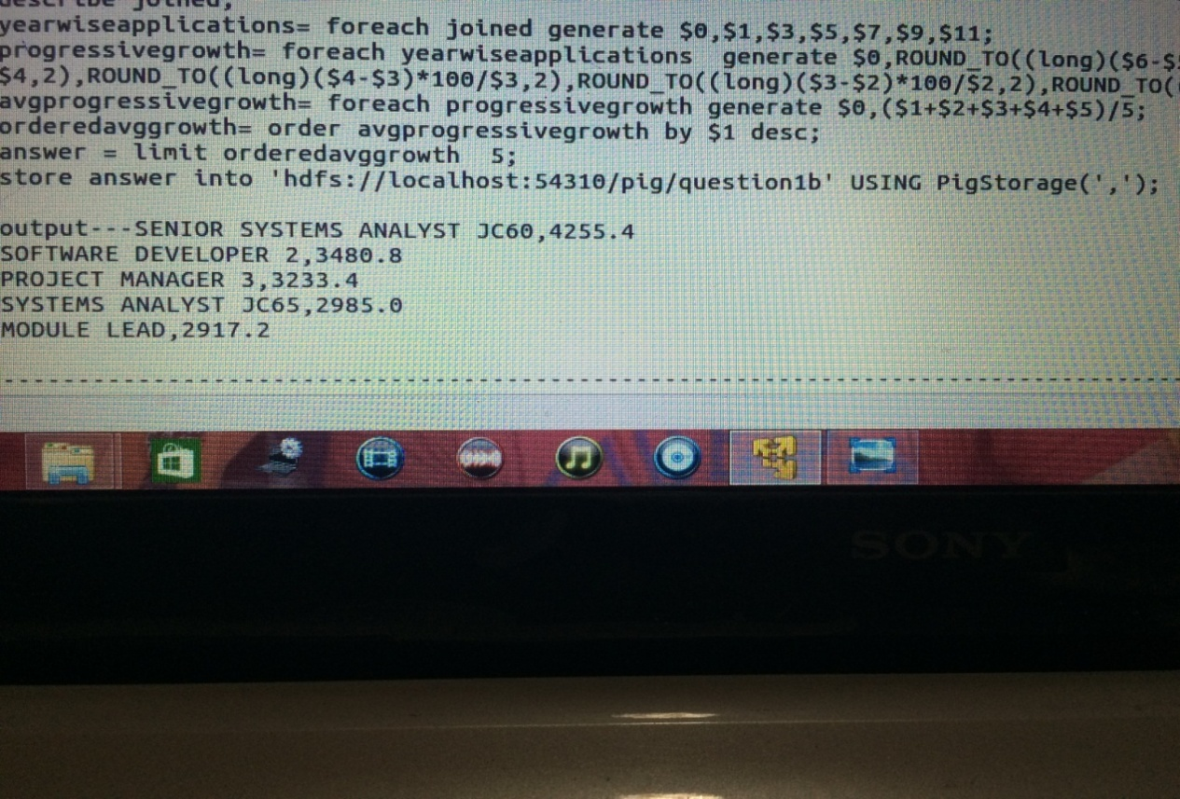

**6) Find the percentage and the count of each case status on total applications for each year. Create a line graph depicting the pattern of All the cases over the period of time?**

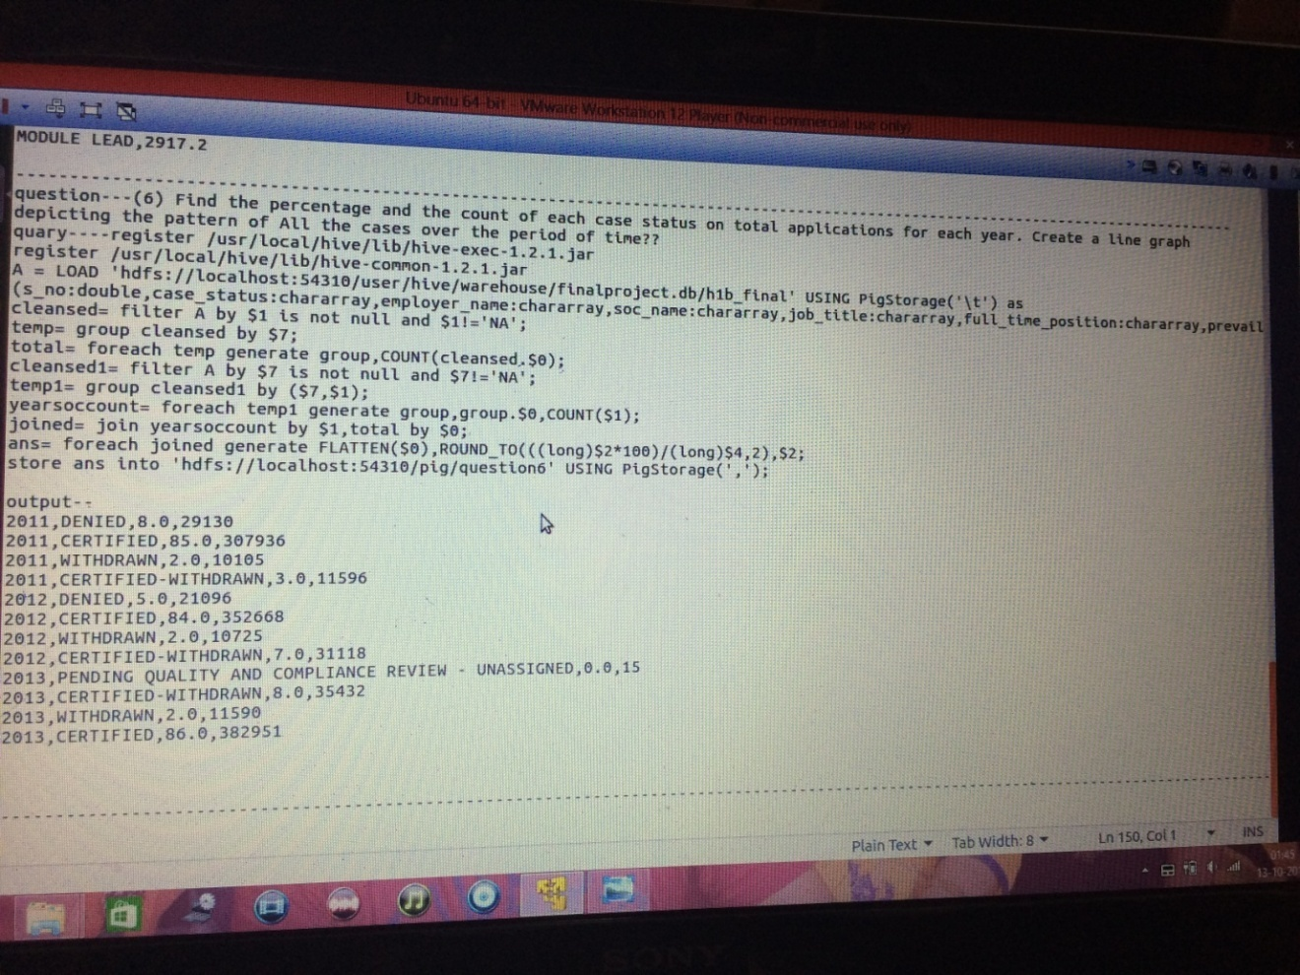

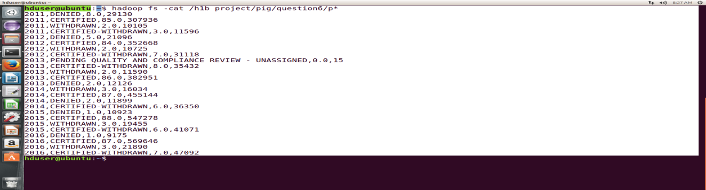

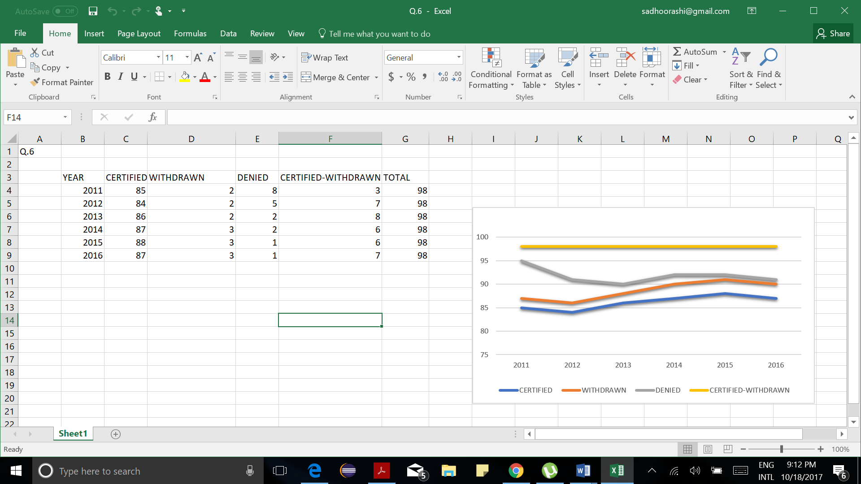



**9) Which are the employers along with the number of petitions who have the success rate more than 70% in petitions. (total petitions filed 1000 OR more than 1000)?**

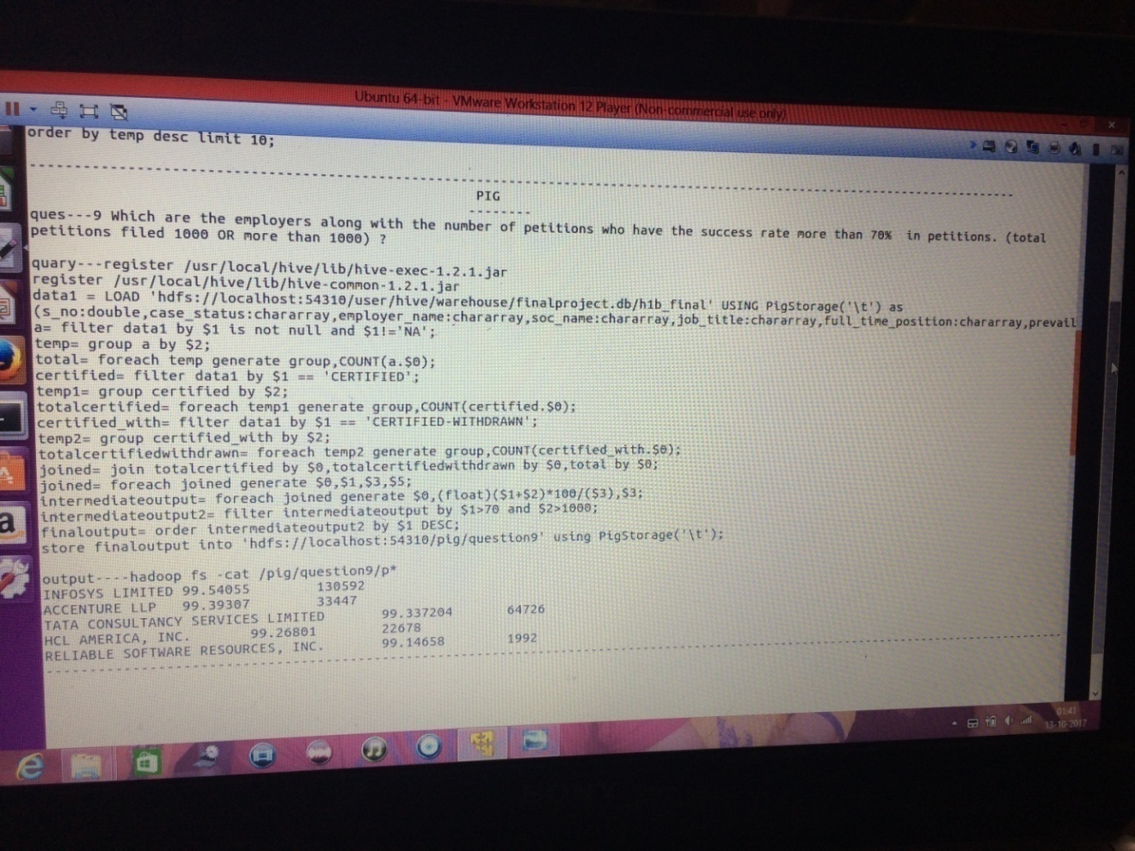

**10) Which are the job positions along with the number of petitions which have the success rate more than 70% in petitions (total petitions filed 1000 OR more than1000)?**

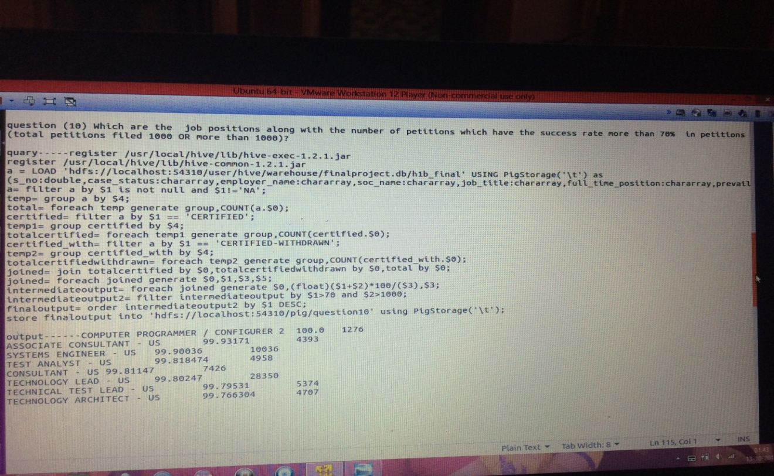

**HIVE**

**2 b) find top 5 locations in the US who have got certified visa for each year.[certified]**

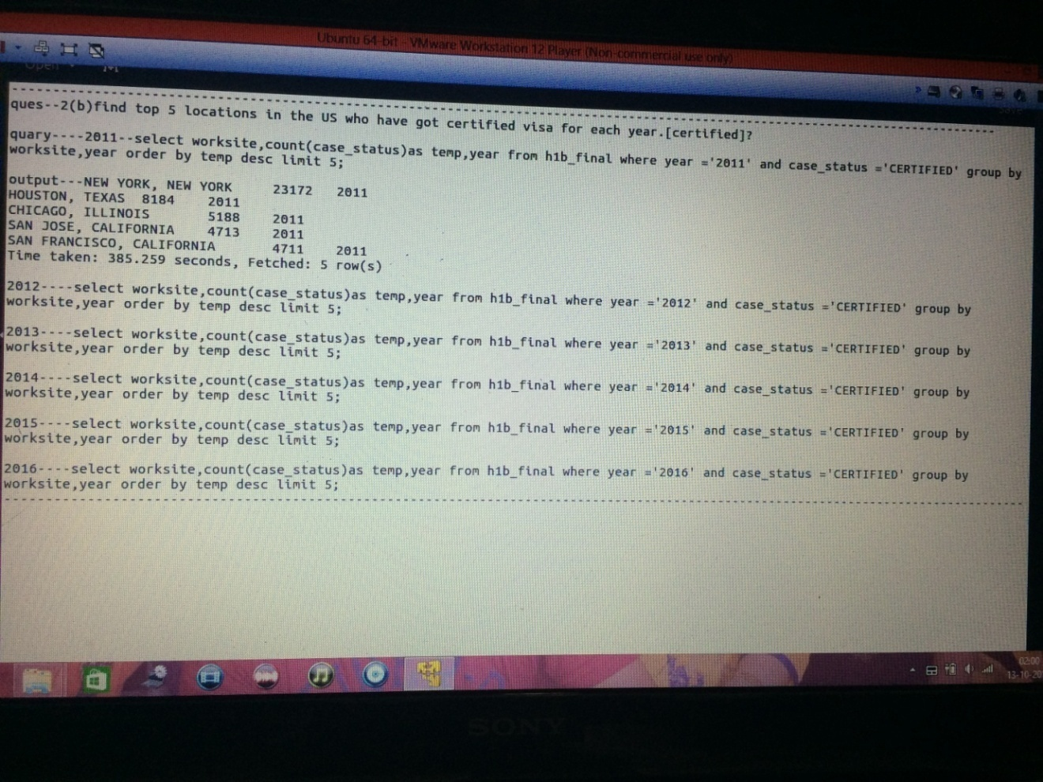

**-------------------------------------------------------------**

**5) Find the most popular top 10 job positions for H1B visa applications for each year?**

**(a) for all the applications**

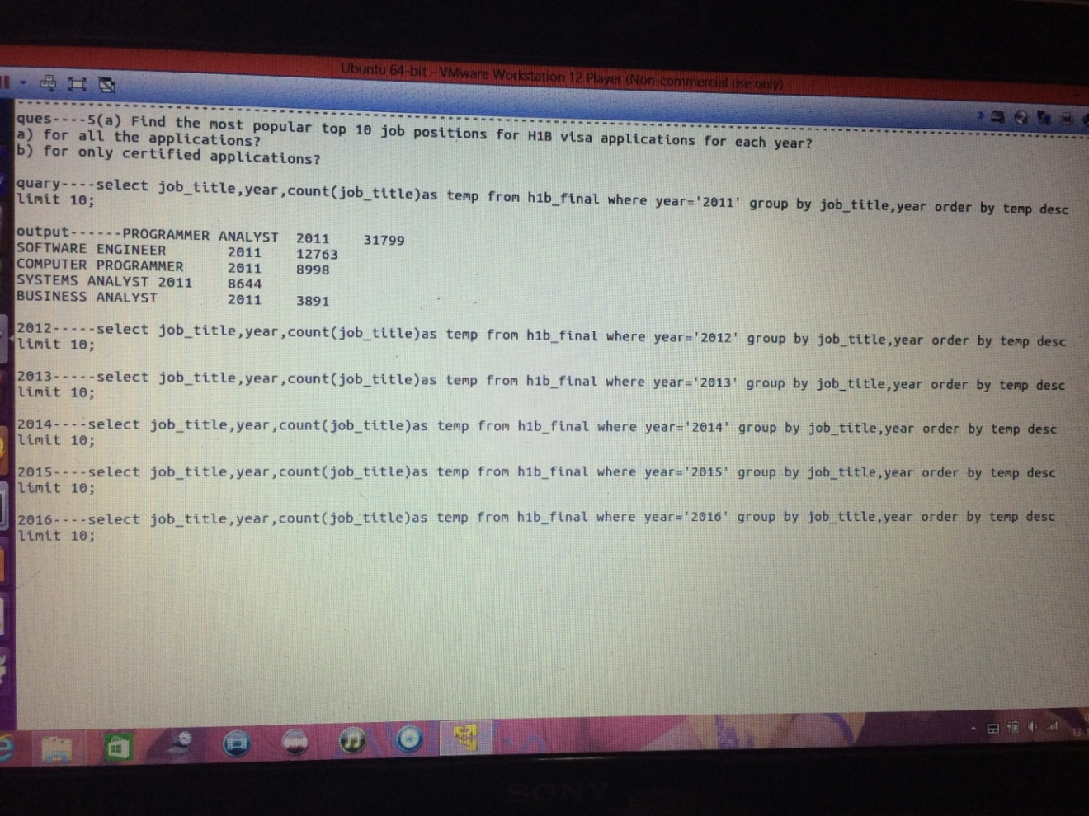

**5 (b) for only certified applications?**

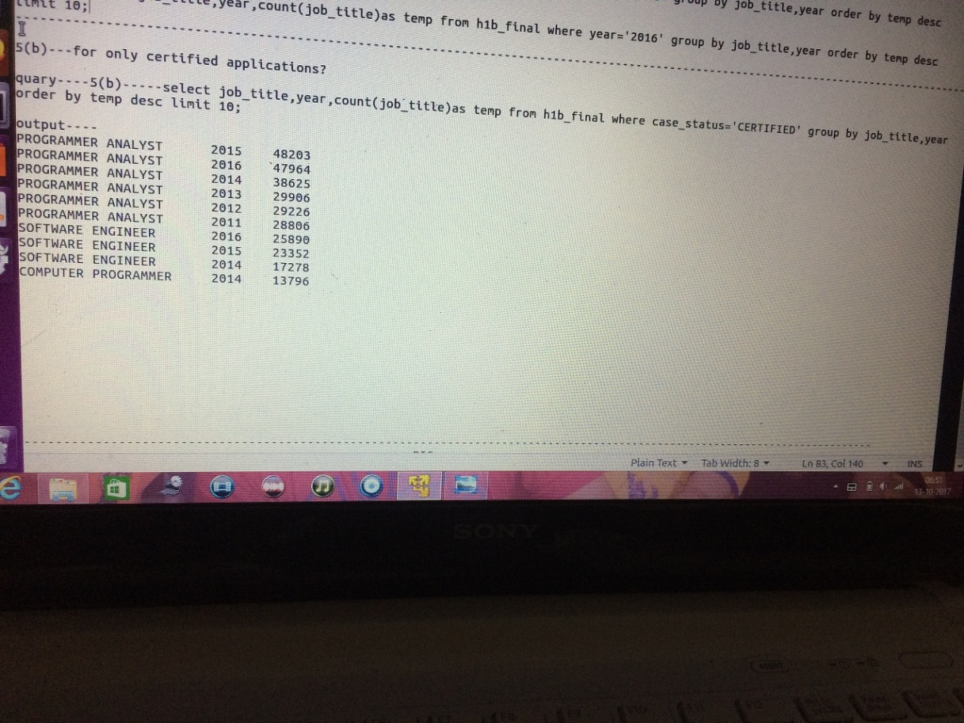

**7) Create a bar graph to depict the number of applications for each year [All]**

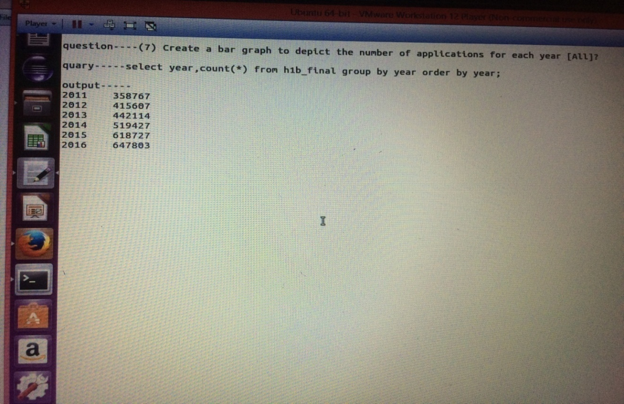

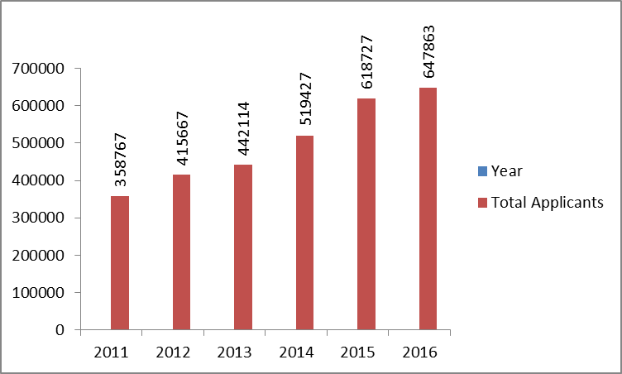

**8) Find the average Prevailing Wage for each Job for each Year (take part time and full time separate). Arrange the output in descending order - [Certified and Certified Withdrawn.]**

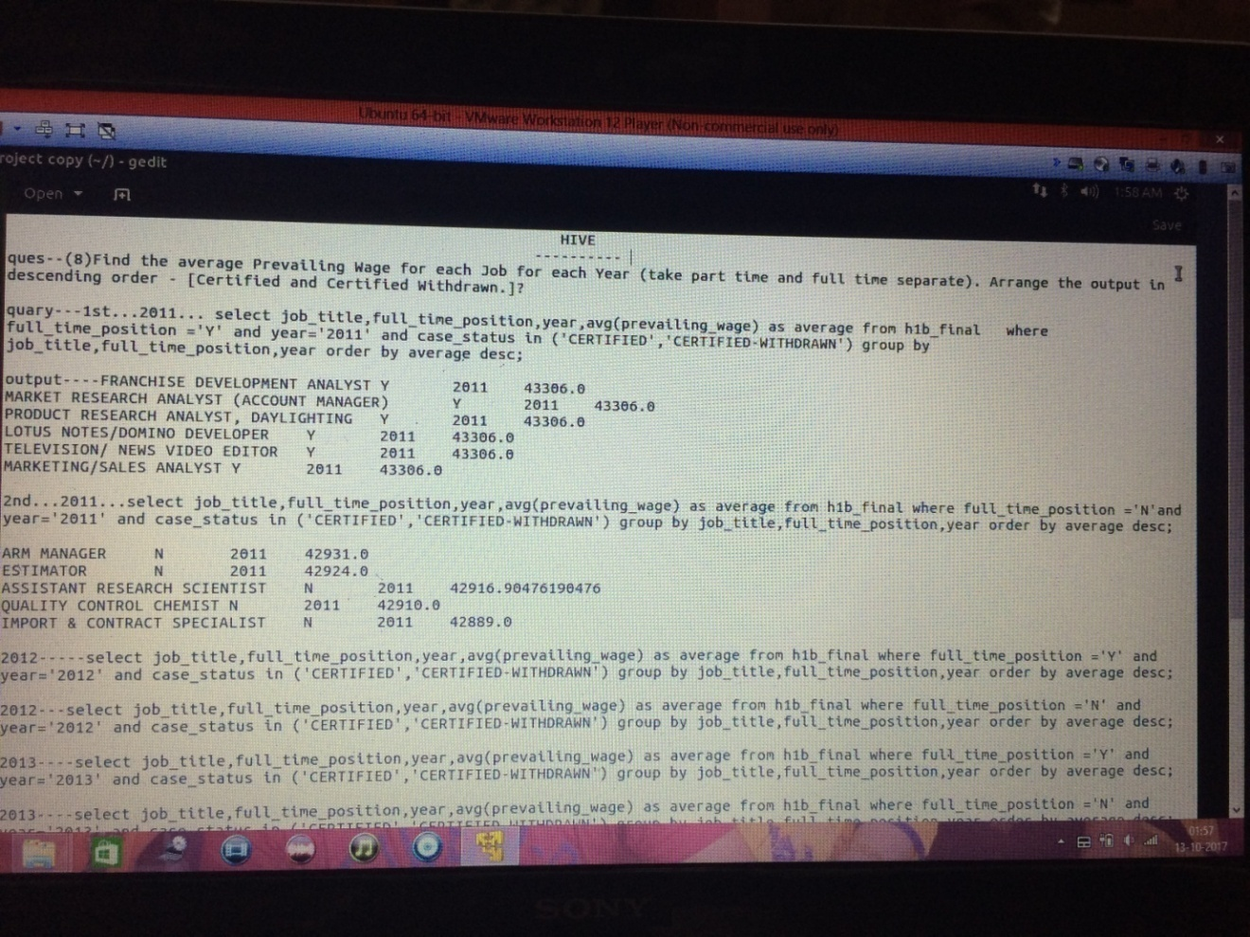

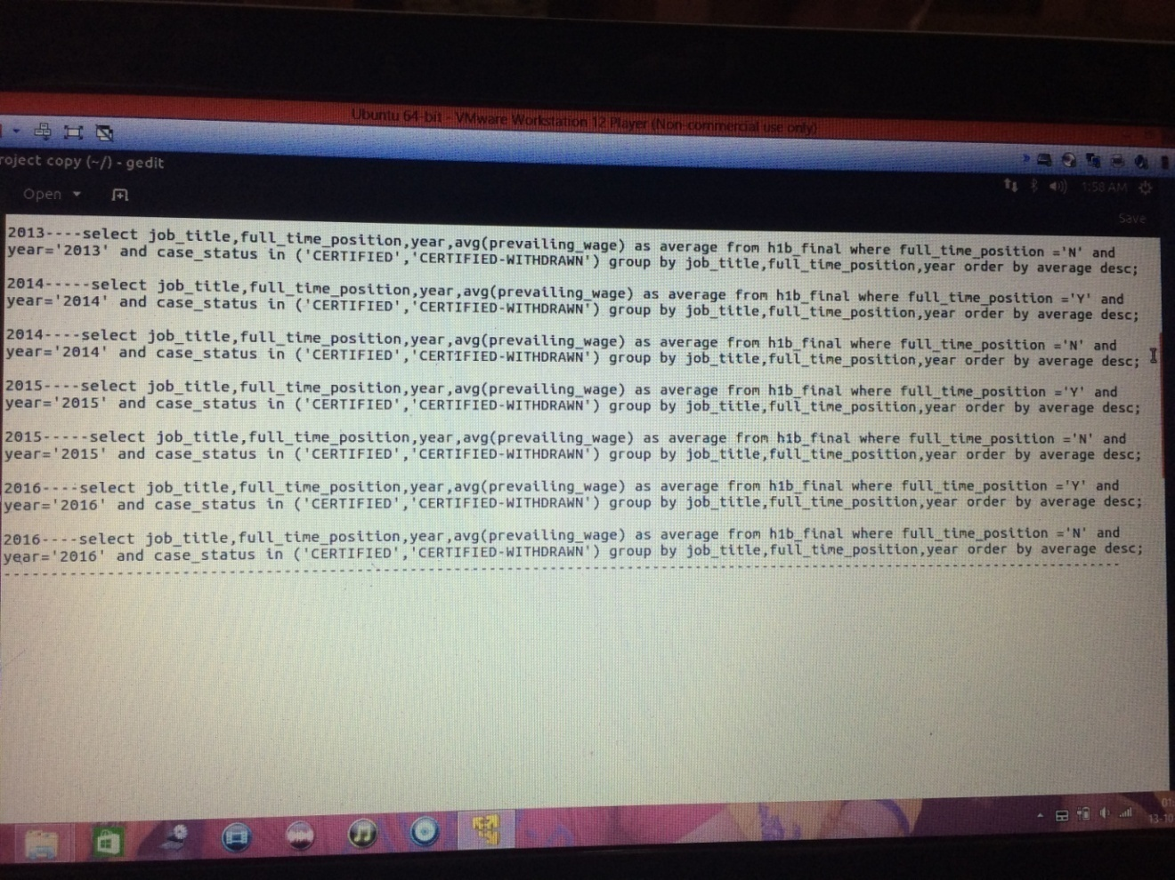

MAPREDUCE

**Question 2(a) – Which part of the US has the most Data Engineer Job for each year?**

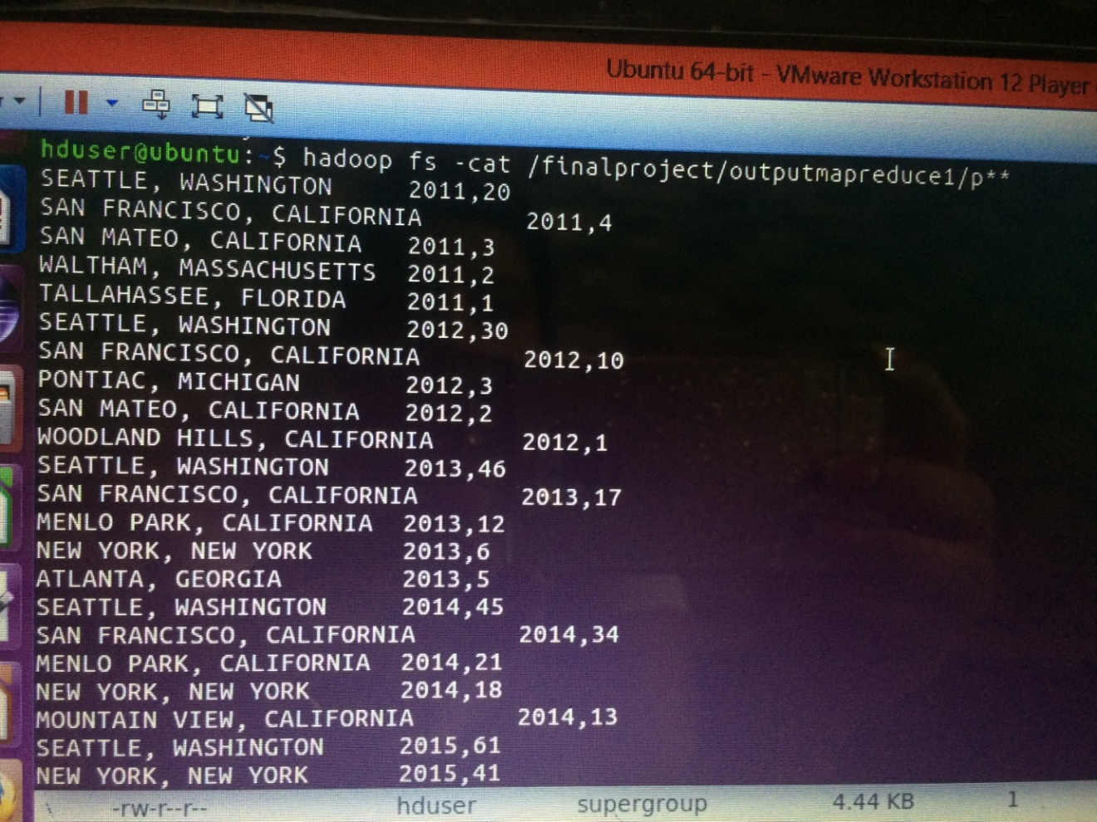

**Question –(3) Which industry (SOC_NAME) has the most number of Data Scientist Position?[Certified]**

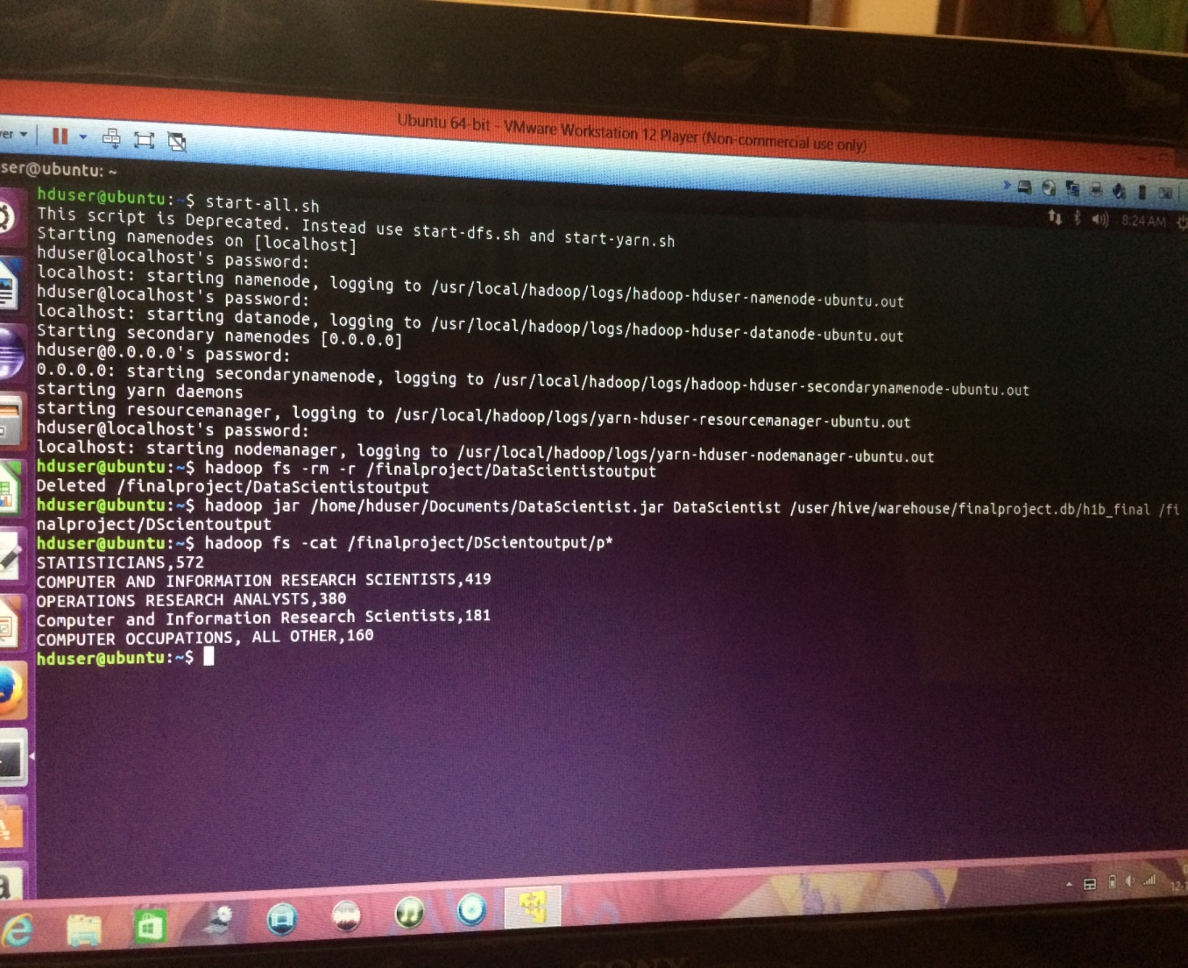

**Question 4—Which top 5 employer file the most petitions each year Case Status—ALL??**

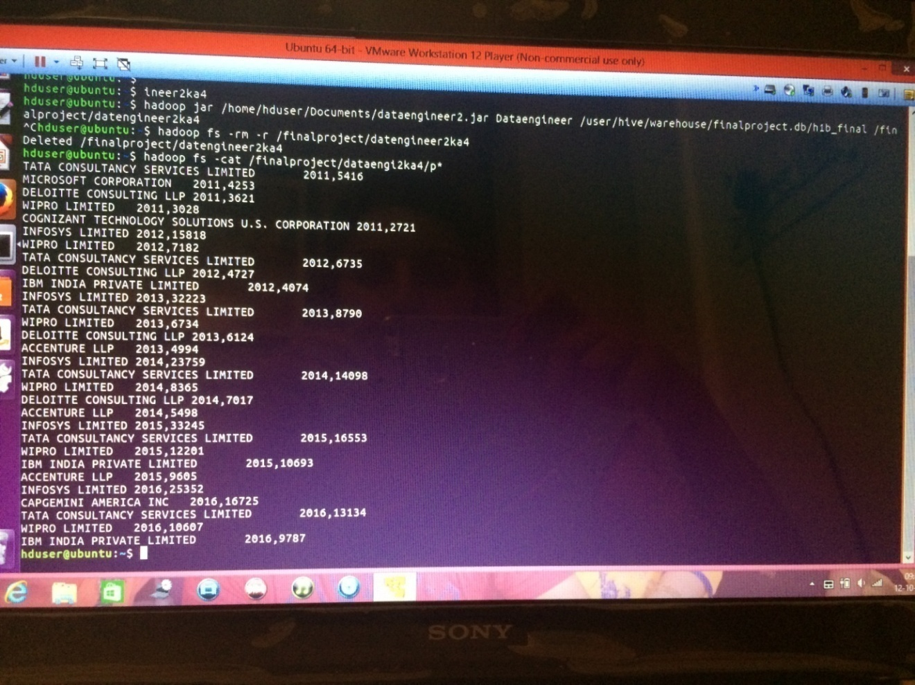

**Question 1-(a) Is the number of petitions with Data Engineer job title increasing over time?**

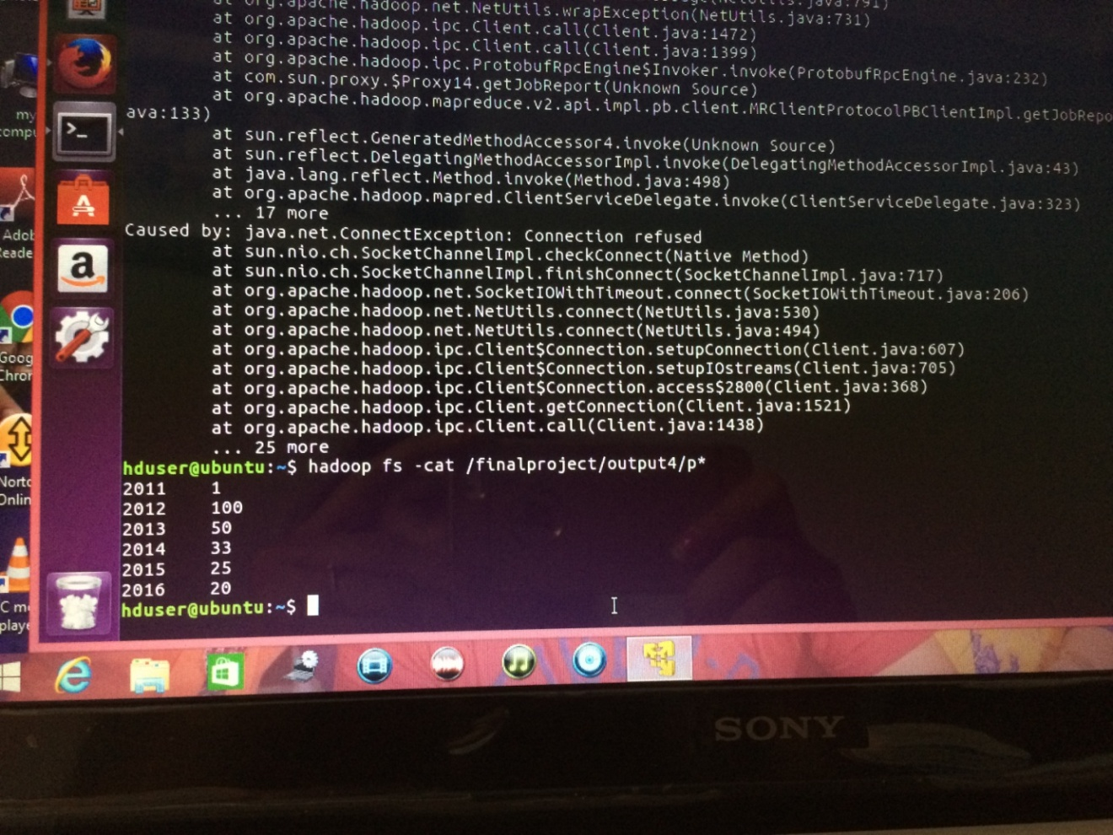

**11) Export result for question no 10 to MySQL database.**

Solution:

Quary –sqoop export --connect jdbc:mysql: //localhost/h1b_final -–username root --password linux --table question11 --update-mode allowinsert --export –dir /pig/question10/p* --input-fields-terminated-by ‘|\t’ ;

Output show--- mysql -u root -p -e ‘select * from h1b_final.question11’;

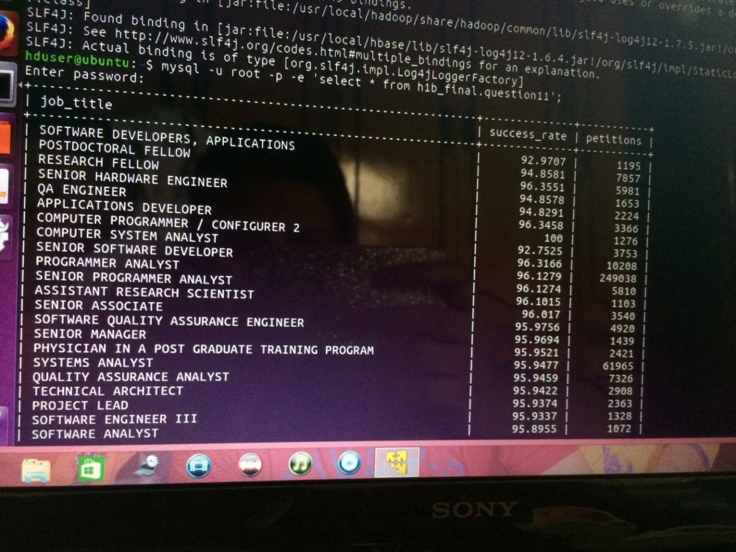

**CONCLUSION:**

**Therefore from the given dataset H1-B applicants within the years 2011-2016,which contained around 3 billion that is 3lakh records ,we have done a complete analysis on various factors which has predictive nature .This analysis on the H1-B VISA data set has resolved around finding top Occupation ,States,Employers,Industries the contribute to highest number of H1-B VISA . This clearly indicates the H1-B VISA filings which has a high correlation with the employer’s rate.**